**Modeling Nearshore Fish Community Response to Shoreline Types in Lake Erie**

*Martin A. Simonson, Christine M. Mayer, Song S. Qian, Kristin K. Arend, Jonathan M. Bossenbroek*

**Abstract:**

Approximately 80% of fishes from the Laurentian Great Lakes use the nearshore zone in some way (e.g., feeding, spawning, or nursery area) for at least part of the year. Extensive shoreline alteration and development along Ohio's Lake Erie coast have reduced habitat complexity and changed ecological connections at the interface of land and water. We hypothesized that shoreline features affect the nearshore fish community composition and distribution. To determine relationships between shoreline types and the nearshore fish community, habitat features such as terrestrial vegetation, shoreline armor structure and a shoreline’s exposure to wave energy were classified at 51 coastal sites in the western and central basins of Lake Erie where fish were sampled between 2011 and 2016. Changes in the predicted total and relative abundances of nearshore fish community groups were modeled based on these shoreline classifications. We found that wave energy was negatively correlated with fish species richness as well as total abundance of nearly all fish groups. Shoreline vegetation was inversely related to wave energy but positively associated with nearshore fish species richness and abundance of rare taxa. Shoreline armoring was uncorrelated with wave energy and was also positively associated with nearshore fish species richness at low exposure to energy, however, armoring led to more homogeneous fish communities at high wave energy. Understanding the impacts of shoreline modification on nearshore fish community attributes is critical to employing best management practices that protects and sustains nearshore fish habitat.

**Introduction**

The quality of lakes as fish habitat depends on a variety of physical and chemical factors, (Tonn and Magnuson 1982, Tonn 1990). In particular, the nearshore zone (<5m; (Mackey and Liebenthal 2005)) of large lakes provides a critical habitat for many species of fish because it is physically diverse and productive due to its transitional position between upland and pelagic ecosystems (Jude and Pappas 1992a, Brazner and Beals 1997). In the Laurentian Great Lakes, approximately 80% of fishes use the nearshore in some way (e.g., feeding, spawning, or nursery area) for at least part of the year (Reid and Mandrak 2009). However, the coastlines of many large lakes support large human populations (Cohen and Small 1998), and the nearshore zone tends to be highly augmented. Therefore, habitat quality for fish is likely affected by human activities along the coastline. Of the 32 largest cities in the world, 22 are located on estuaries (Ross 1995). Knowledge of how human-driven habitat alteration influences the abundance and distribution of fish communities in the nearshore zone is essential to a clearer understanding of lake-wide ecosystem function.

One of the most common shoreline alterations is armoring, which has been employed by coastal communities worldwide. As coastal communities become more developed and urbanized, many residents, industries, and municipalities attempt to arrest erosion with the use of hard structures. Armored shorelines in the Great Lakes are common. In particular, the United States Lake Erie shoreline is almost 83% protected or artificial (Forgette et al. 2011). Lucas County, Ohio has a shoreline that is more than 98% artificial (Federal Emergency Management Agency 2013). Armor can add structure to homogenous coastlines and may provide beneficial habitat structure to some fish species similar to the way that among-lake heterogeneity correlates with species richness (Tonn and Magnuson 1982, Keast and Eadie 1984). However, armor can increase coastal wave energy when it eliminates the shallow, gradual slope of coastlines, areas which also provide refuge for small fish. The slope of armoring, in addition to the material from which it is made, affects nearshore fish community distribution by providing diverse micro-habitats and levels of exposure to wave energy.

Another common shoreline alteration is vegetation removal from the water’s edge. Coastal vegetation is a principal biotic component of shoreline habitat. Initial research on terrestrial vegetation on the United States shoreline of Lake Erie indicated that the presence of coastline vegetation was associated with increased fish diversity (Ross 2013). Yellow perch (*Perca flavescens*), northern pike (*Esox lucius*), and smallmouth bass (*Micropterus dolomieu*) have all been observed spawning at coastlines with dense vegetation (Trautman 1981). Emergent vegetation provides structure and therefore refuge for small bodied fish and more abundant invertebrate food. Alternately, larger predators may have cover to improve capture success (Diana 2004, Strayer and Findlay 2010). Further, shoreline vegetation stabilizes soil and therefore may improve nearshore water quality while also reducing erosion. Despite the multiple beneficial functions of shoreline vegetation, removal (including coarse woody debris or driftwood) is a common coastal alteration, often implemented to maintain landscaping and aesthetic lake views, maximize lifespan of riprap, and maintain recreational beaches. Understanding how the interactions between different shoreline alterations impact habitat use and productivity of fisheries within coastal systems is integral to shoreline restoration and enhancement.

While habitat alteration may affect the nearshore fish community, other biological and physical factors should be considered in trying to understand the effect of habitat alteration. Submerged aquatic vegetation (SAV) is associated with higher fish species richness (Uzarski et al. 2005). The structure provided by SAV allows small fish to feed in a protected environment (Werner et al. 1983, Werner and Hall 1988). The location and establishment of aquatic plant species are dependent on a number of physical and geological factors such as wave energy and substrate, which play a key role in structuring aquatic macrophyte and ultimately fish communities in lakes (Cyr 1998, Koch 2001).

Wind and wave energy are physical processes that influence the biodiversity and fish community structure at nearshore habitats (Henning et al. 2014). Establishment of terrestrial and aquatic vegetation, as well as the shoreline modification chosen by landowners, are often related to a coastline’s exposure to wave energy. The amount of physical energy that shorelines are exposed to is not uniform across the lake, ranging from protected embayments and harbors to open lake bluffs and beaches. A diverse fish species assemblage that is dependent on aquatic macrophytes has been observed at protected nearshore zones where those plants can establish, while open lake sites provide different habitat utilized by other fish species (Jude and Pappas 1992a, Seilheimer and Chow-Fraser 2006, Henning et al. 2014). The physical and biological processes that shape coastal habitat must be considered in conjunction with the alterations of armoring and vegetation removal.

To understand the biological performance of nearshore fish habitat in Lake Erie, different metrics of the fish community were examined. Broadly, these relate to how many of what types of fish use the different habitat categories. Species richness, or number of fish species, is a quick measure of fish habitat but lacks description of how the fish community is structured. The relative abundance of fish species or species groups may indicate increases or declines in fish abundance that are not apparent from simple species richness. Changes in fish habitat will not affect fish uniformly, as some fish species are more tolerant to a wide range of conditions compared to sensitive fish that have strict habitat requirements. Therefore, both the total and relative abundance of fish taxa address biological performance of shoreline habitat in different, informative ways.

The goal of this study is to identify relationships between different shoreline habitat types and the nearshore fish community distribution in Lake Erie. The specific objectives include comparing the interactive effects of shoreline armoring and vegetation types, given exposure to wave energy, on nearshore species richness as a measure of biodiversity. Once the combinations of shoreline habitat features that influence species richness have been identified, changes in the total and relative abundance of fish groups can be modeled using generalized linear models that estimate taxa abundances in response to shoreline types. The nearshore fish community in the Great Lakes is taxonomically diverse and condensed species groups provide simplified insight into how coastal habitat influences the fish community composition of the nearshore zone. The relationships between changes in fish community structure and shoreline alteration will improve understanding of fish habitat restoration and enhancement efforts in Lake Erie.

**Methods**

*Data Collection*

The abundance and composition of the nearshore fish species were indexed using night electrofishing following an established sampling protocol in use by the Ohio Department of Natural Resources Division of Wildlife (Ross et al. 2016). The vessel was a 7 m aluminum boat with a 120 volt, 5000-watt generator operated at 60 Hz with a 5.0 GPP Smith-Root control box. Electrofishing was conducted with DC current at 60 pulses per second. Power was adjusted for varying conductivity conditions to target 5-6 amps, generally ranging from 40% to 60% power. Electricity was transferred through the water by anodes on each of two booms extending out from the bow at a 25° angle with wires arranged in an umbrella array submersed one foot below the water.

Nearshore sites (n=51) were sampled between June 1 and August 31 from 2011 to 2016, although not every site was sampled annually due to the limitations of time, labor, and weather. Beginning a half hour after sunset, electrofishing was conducted following the 1-2 m depth contour along 500 m of shoreline, which translates to about 1000 seconds of effort per sample. Electrofishing was conducted at idle speed with a crew of two dip netters on the bow of the boat and one boat operator. All stunned fish were netted and placed into an aerated livewell and processed at the end of each sampling site. Fish were identified to species, enumerated, and weighed (g) in the field whenever possible. Prominent sportfish (e.g., smallmouth bass, bluegill (*Lepomis macrochirus*), walleye (*Sander vitreus*)) were weighed and measured for total length (mm) individually; most other species were batch weighed for an average estimate of biomass. Any rare species were euthanized using Tricaine-S (MS-222) following American Veterinary Medicine Association protocol and preserved frozen as voucher specimens (Leary et al. 2013).

Previous research suggested that vegetated shorelines had higher fish species diversity than other areas (Ross 2013). However, the sampling was not designed to identify specific shoreline armoring and vegetation features. At five 100 m transects within each site, oblique photos of the shore were taken using a GPS-enabled digital camera. The photos were examined using image processing software to measure the linear extent of different armor and vegetation types, calibrated to a 1m long fluorescent orange plank of wood set on shore. The coastal armor and vegetation type was classified by determining which type was present along 60% or greater of the entire 500 m sample site.

Shoreline armor classifications were Unarmored, Groin, Flat, and Riprap. Unarmored shorelines had no artificial structure, while Groin sites had perpendicular structures designed to arrest sediment transport alongshore. Flat sites were both natural (e.g., limestone cliffs) and artificial (e.g., steel sheet piling) but were functionally similar. Both these shorelines lack a shallow zone and reflect a majority of wave energy. Riprap was the most abundant armor type in the lake, where cement rubble and boulders are placed on shore to stop erosion.

Shoreline terrestrial vegetation classification was limited to the plants located within 1 m of the interface of land and water. The terrestrial vegetation categories were No Vegetation, Grasses (herbaceous emergent vegetation) and Mixed (woody trees and shrubs with herbaceous undergrowth). Submerged aquatic vegetation categories were determined using hydroacoustic sonar and plant collection via leaf rake, calculating the extent of plant coverage and height of the aquatic plant canopy. If a site exhibited more than 60% plant coverage that was also greater than 10 cm high, the site was determined to have SAV present. If a site did not meet both criteria, it was classified as No SAV.

The estimate of wave energy is compared between sites through the calculation of a Relative Energy Index (REI), which uses fetch distance and known wind data such as speed, direction, and duration to calculate exposure to wave energy (Wang et al. 2015). A composite estimate of wave energy was calculated for all waters less than 5 m deep for the Laurentian Great Lakes. The Relative Energy Index value selected for each site was obtained by overlaying a site’s latitude and longitude on top of the REI data layer. At the 500 m scale of this research, a data layer applied to the entire Great Lakes shoreline did not vary and the median REI value was assigned to that site.

*Data Processing and Analysis*

To determine if fish diversity differed among shoreline types, we first compared species richness (the number of species present in the sample) to each of the shoreline factors individually. Following that, the factors were combined to explore possible interactions between shoreline conditions. Since this exploratory data analysis relies on unbalanced samples and there is no manipulation of factors, inferential statistics and p-values do not apply.

Grouping taxa makes interpretation and discussion of model results simpler, especially for different management goals and objectives. Creating over fifty independent regression models would complicate discussion of results and could mask broader community trends. Therefore, we grouped taxa by similar ontogeny and phylogeny to observe how the groups respond to different shoreline types (Table 1). First, the count data were split into three broad categories: Ubiquitous, Responsive Taxa, and Rare. Ubiquitous fish were those species that were present in over 75% of all samples. These fish are widespread and abundant, with no discernable response to shoreline features. Alternatively, the Rare group comprises those fish species that were only found in fewer than 20% of the samples. These fish were observed so infrequently that there is not a large enough sample size to compare responses to different shoreline types.

The Responsive Taxa group comprises those fish species found in at least 20% of the samples but fewer than 75% of the samples. Within this group, fish were further divided into taxa classifications based on similarities in phylogeny and ontogeny. For species of recreational interest (e.g., largemouth bass, smallmouth bass), shoreline comparisons were made at the individual species level.

**Table 1**: Nearshore fish species grouping with example taxa..

|  |  |  |
| --- | --- | --- |
| Nearshore Fish Grouping | | |
| Rare Taxa | Responsive Taxa | Ubiquitous Taxa |
| n = 1,328 | n = 7,577 | n = 17,042 |
| Example taxon:   * Silver redhorse * Northern hog sucker * Brook silverside * Creek chub | Subgroups:   * Carp & Goldfish n=839 * Catfish & Bullhead n=286 * Darter n=128 * Round goby n=114 * Largemouth & Smallmouth Bass n=1,161 * Minnows n=2,121 * Other sunfish n=1,876 * Suckers n=379 * White bass n=430 * Walleye n=107 * Yellow perch n=136 | All Taxon:   * White perch * Emerald shiner * Gizzard shad * Freshwater Drum |

*Statistical Analysis*

The generalized linear model (REF) was used as the basic tool for data analysis to evaluate changes in fish community diversity (measured by species richness), abundance (total abundance of individual species and groups), and fish community structure (relative abundance of fish species and species groups). Because the raw data were counts of individual species sampled at each sample event, the Poisson distribution was used as the basic probabilistic model. Multilevel Poisson regression models (REF) were used for species richness and for total abundance. The Poisson-Multinomial transformation (REF) was used to model relative abundances.

A generalized linear model with Poisson response variable distribution was used to compare the linear relationship between fish species richness or abundance and REI, among different armor and vegetation categories. This approach tests whether the relationship between abundance and wave energy, an important naturally varying physical factor, changes with habitat alteration. Specifically, the observed count data for the species richness or individual species group *k* are assumed to follow a Poisson distribution:

yi ~ Pois( λik) (1)

The Poisson distribution parameter λikis modeled by REI:

log (〖 λ〗_i^k ) = α_(0j[i])^k+ α_(1j[i])^k *〖 log(REI〗_i)

(2)

The logarithmic predicted number of species or fish was modeled by a linear function of potential predictors. We used log REI as the single continuous predictor and allowed the intercept and slope to vary by shoreline armor and vegetation types. REI was log-transformed to make the REI values more evenly distributed on the x-axis due to many low REI values and few high REI values. In equations (1) and (2), the index *i* represents observations, *j* represents shoreline type category, and *k* represent species groupings. The notation j[*i*] represents that the *i*th observation was taken from a site in the *j*th shoreline type. The modeled intercept and slope were α_0 and α_1, respectively; these parameters vary by shoreline habitat classifications to compare differences in fish community structure.

The Poisson model is often used for count variables and estimating, for example, the total abundance of a species or species group. The community structure of nearshore fish, specifically the changes in species assembly and taxa groups, provides broader-level analysis of fish response to shoreline alterations. Data were summarized through an exploratory data analysis to examine responses to shoreline type by both species richness and total fish abundance (all species). Distribution of samples according to shoreline habitat features and REI was examined for inclusion into the multilevel Poisson models that estimated total abundance. Once the total abundances of each taxa group were estimated, the changes in fish community structure were evaluated by calculating relative abundance through the Poisson-multinomial connection (Qian 2016).

The fish community assembly was compared through relative abundance of fish, which is especially important when there are spatial limitations to habitat. Increased competition for resources leads to exclusion of less competitive taxa, which in turn has implications for habitat-based management. The Poisson-Multinomial transformation converts the predicted total abundances of each species group into their relative abundances. This conversion is based on the mathematical connection between the Poisson distribution and the multinomial distribution (Agresti and Kateri 2011). The relative abundance of species group *k* is the ratio of the expected total abundance of the same group divided by the sum of expected abundances of all groups:

〖Relative Abundance〗_i^k= (λ_i^k)/(∑_k▒λ_i^k )

 (3)

The Poisson regression model was implemented using the bayesglm() function in the package armwithin the R statistical computing software (Gelman and Su 2016, R Core Team 2016). The bayesglm() function is chosen because it constrains the regression coefficients from reaching unrealistic values (Gelman and Su 2016).

**Results**

*Species Richness and Total Abundance*

The nearshore fish monitoring program has collected a total of 26,947 individuals comprising 51 species or hybrids from 130 sample events between 2011 and 2016 (Table 1). Fish species richness was observed to vary most at Unarmored and Riprap sites, suggesting that there is an interaction with other covariates such as REI, which is loosely negatively correlated with species richness (Figure 1). For both SAV and terrestrial vegetation categories, fish species richness was lower at non-vegetated sites; however, there was no discernable pattern between vegetation types (Figure 1). There is an additional effect of the sample size on the number of species observed in that higher samples have higher species richness. Therefore, the sample size can be used as an offset in the Poisson model (Equation 2).

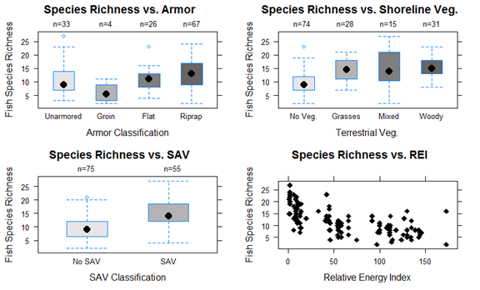  
**Figure 1**: Box and whisker plots for fish species richness compared to shoreline armor, vegetation types, and exposure to wave energy.

There appears to be a wave energy threshold for the establishment of SAV (approximately REI=50; Figure 2). Disturbance from wave energy is one of the most common physical factors influencing the establishment of coastal vegetation. Rooted aquatic vegetation (SAV) is more likely to be washed away at high energy environments. Therefore, these two covariates were likely confounding, and the categorical aquatic vegetation category was discarded in favor of the continuous REI variable.

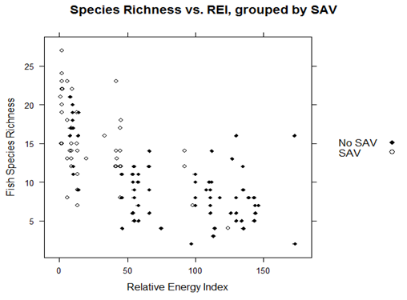

**Figure 2**: Scatterplot of fish species richness compared to the Relative Energy Index, grouped by the presence of submerged aquatic vegetation.

When the Armor and Terrestrial Vegetation categories were combined, species richness increased at Unarmored and Riprap sites with vegetation, again with no discernable trend in vegetation type. Plant/armor interactions could not be assessed at sites with Groins or Flat structures due to a general lack of vegetation (Figure 3). Therefore, Groin and Flat sites were removed (N=30) from abundance analyses using the Poisson general linear regression.

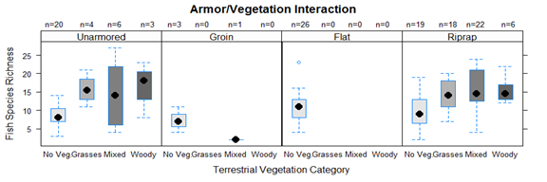

**Figure 1-3**: Box and whisker plots for fish species richness compared to shoreline vegetation, grouped by armor category.

The total abundance of fish across all species did not have a discernable pattern in relationship to any of the shoreline factors alone (Figure 4). This provides support for interaction among the shoreline habitat predictor variables. Additionally, this indicates that analysis of changes in relative abundance of individual taxa groups will be more informative than simple analysis of the counts of species or individuals. REI was not a primary factor influencing fish community in the nearshore zone, rather, the heterogeneity in coastal habitats and shoreline types influence fish distribution interactively. This exploratory data analysis indicates that regardless of wave energy, individual shoreline features have at least some influence on species richness, therefore, shoreline armoring and vegetation can be retained in the Poisson regression models.

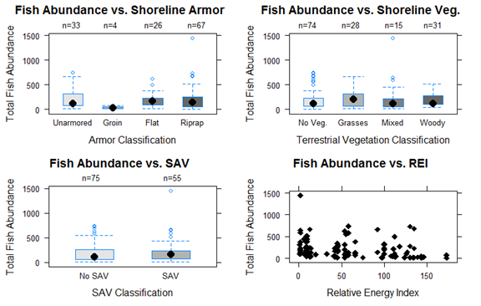

**Figure 1-4:** Box and whisker plots for total fish abundance of all species, compared individually to shoreline types and exposure to wave energy.

Using the multilevel Poisson regression, coefficients for species richness in response to REI based on shoreline type were estimated (Figure 5). The greatest difference in the number of species by shoreline type occurred at low energy environments. The only shoreline type that did not result in a decline in species richness with REI was riprap sites with vegetation. Conversely, sites armored with riprap but without vegetation present had a negative association between species richness and REI, indicating that shoreline vegetation is positively associated with species richness. Of the shoreline types where the number of species present declined with REI, unarmored sites without vegetation had the lowest rate of decline.

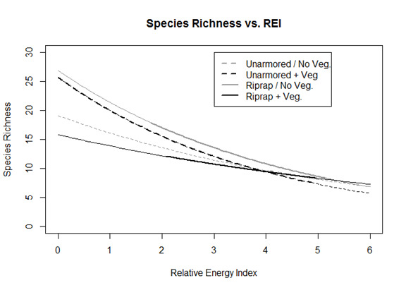

**Figure 5**: Comparison of estimated species richness in response to log-transformed Relative Energy Index, separated by shoreline armoring and vegetation categories. Bolded sections of the line indicate observed data ranges.

The independent Poisson regression models for each species group yielded different coefficients for slope and intercept in response to REI based on shoreline type. The four different shoreline categories were not evenly distributed across all wave energy conditions. Therefore, the model used likelihoods from other shoreline conditions to extrapolate how the total abundance of taxa groups changed in response to wave energy at different shoreline habitat categories. The models for Darter, Goby, Minnow, Sucker, White Bass, Walleye, and Yellow Perch taxa groups did not return meaningful coefficients for REI or shoreline type (p > 0.1). The Responsive Taxagroups analyzed were Carp/Goldfish, Catfish/Bullhead, Largemouth/Smallmouth Bass, Other Sunfish, Rare and Ubiquitous.

Ubiquitous species had the highest modeled total abundance of all the taxa groups. This was not surprising, as the individuals from these four species account for half of all species sampled. At vegetated sites Ubiquitous abundance declined linearly with wave energy, but there was little to no decline in Ubiquitous species at non-vegetated sites (Figure 6). The abundance of Rare taxa, alternatively, declined sharply with REI and only had abundance comparable to other taxa groups (e.g., greater than 50 individuals) at sites with riprap and vegetation (Figure 6).

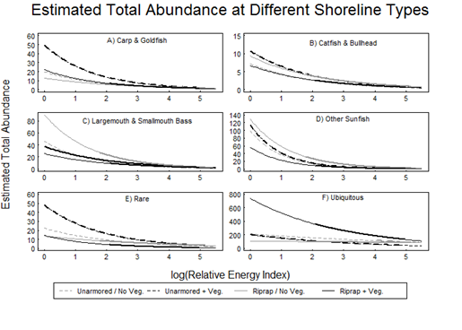

**Figure 1-6**: Estimated total abundance of fish taxa groups in response to log(REI), grouped by armor and vegetation category. Note the changes in scale for the y-axis. Dashed lines represent unarmored sites, while solid lines represent sites armored with riprap. Grey lines are non-vegetated; black lines are vegetated. Bolded sections of lines represent data ranges, lines outside of bolded sections are extrapolated data.

At low REI values common carp (*Cyprinus carpio*) and goldfish (*Carassius auratus*) had highest total abundance at riprap sites with vegetation, but lowest total abundance at non-vegetated riprap sites. Similarly, unarmored sites with vegetation had higher carp and goldfish abundance compared to unarmored sites without vegetation (Figure 6). Catfish and bullhead taxa had the lowest total abundance counts overall, but when compared to the other shoreline categories riprap sites with vegetation had nearly double the amount of these species at low wave energy. The other three shoreline conditions have consistently low abundance across all REI values (Figure 6).

Largemouth and smallmouth bass, both prominent sportfish in Lake Erie, still decline as a function of REI, but have highest abundances and lowest rate of decline at riprap sites, especially without vegetation (Figure 6). The apparent trend is that bass prefer heterogeneous habitats with interstitial spaces, perhaps for added foraging opportunity as prey fish have less shallow water refuge at these sites. The Other Sunfish (non-*Micropterus*) abundance declined as exposure to wave energy increased, but at low-energy sites their predicted total abundance was often higher than the other taxa groups, with the exception of Ubiquitous (Figure 6).

*Relative Abundance*

The changes in fish community structure, given exposure to wave energy, was shown to differ by shoreline type. The relative abundance of Ubiquitous taxa increased as REI increased at all shoreline types; however, Ubiquitous species had the lowest relative abundance at unarmored sites with vegetation (i.e., coastal wetlands) at sites with high REI. Ubiquitous fish accounted for 80% or more of the individuals at high wave energy locations (Figure 7). Carp and goldfish had a consistently low relative abundance, comprising less than 10% of the individuals at all shoreline types. Similarly, the Rare and Catfish taxa groups had nearly linear responses to REI across all shoreline types, with each group making up 5% or less of the fish community regardless of exposure to wave energy and shoreline type (Figure 7).

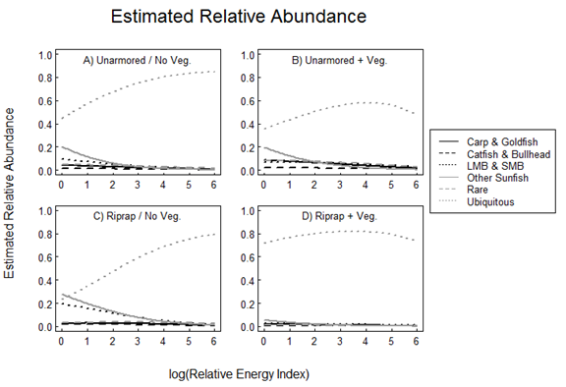

**Figure 7**: Estimated relative abundance of fish taxa groups in response to log(REI), grouped by armor and vegetation category. Note that the data ranges for all four shoreline categories are the same as Figure 1-6, and lines displayed in this figure include extrapolated data.

At protected, low energy sites that are armored with riprap but without established vegetation, Sunfish and Bass each match the proportion of Ubiquitous species. At all other shoreline types with low REI, Sunfish were the second most common taxa. Bass had a higher relative abundance at Riprap sites with and without vegetation, but the decline in bass relative abundance was lowest at riprap sites without vegetation, indicating a positive response to increased physical habitat structure.

**Discussion**

The evidence of shoreline influence on the nearshore fish community was clear at low energy environments, but the effect was less apparent in high energy areas where the fish community was relatively uniform across shoreline types. While there was a general decline in both the number of species and the abundance of most taxa as wave energy increased, the rate of decline differed based on presence of shoreline alterations (armor and vegetation removal). Therefore, the effects of large scale physical factors such as wave energy on the nearshore fish community can be modulated by the presence of shoreline alterations, which have fundamentally changed habitat in the nearshore zone. Through armoring over 80% of the Lake Erie shoreline humans have steepened the slope of the shoreline, which dissipates less wave energy compared to shallow coastlines. This, in turn, leads to a more homogeneous and less diverse fish community in the nearshore zone.

The models presented here rely on extrapolated data; not all shoreline factors are distributed evenly across the gradient of exposure to wave energy. For example, unarmored coastlines without vegetation (e.g., sandy beaches) only exist in high energy environments. Model results for sandy beaches at low energy conditions are derived from sample data combined with averages for that taxa group from other shoreline habitat types. The implications of extrapolated data include conclusions about fish community responses to shoreline types that do not always exist at a given wave energy level. The distribution of shoreline factors along the gradient of wave energy can be used to inform location-based outcomes of shoreline management actions, that is, restoration of habitat for SAV-oriented species is not likely to be effective along reaches of shoreline exposed to high wave energy.

*Species Richness*

Fish species richness did not change substantially with the presence of armor or among armor types. Both unarmored shorelines and those with riprap showed large variation, likely from differences in vegetation (i.e., featureless sandy beaches vs. coastal wetlands). Although sites armored with groins had low fish species richness, these shoreline structures facilitate sediment accretion and therefore have very shallow zones which attenuate wave energy and may also provide valuable refuge area for small fishes. Riprap, the most common armoring type in Lake Erie, had a wide distribution of species richness suggesting an interactive effect with vegetation and other covariates that provide habitat heterogeneity (e.g., sediment, interstitial spaces). Areas in lakes with more complex habitat have been identified as providing both enhanced foraging and enhanced refuge from predation, thereby contributing to increased species richness (Flebbe and Dolloff 1995). Therefore, declines in fish biodiversity as wave energy increases can be mitigated by additional structure and vegetation at the interface of land and water.

Non-vegetated shorelines had high variability in species richness, again suggesting an interactive effect with other habitat features. Vegetated shorelines, regardless of the type of vegetation, had more species present than shorelines without vegetation. Structurally complex biogenic habitats (e.g., wetlands) provide spawning area and refuge for numerous small and juvenile fish species, contrasted by seawalls and breakwaters that reduce complexity of habitats through a lack of boulders and camouflaging sediment or dense marsh vegetation (Gittman et al. 2016). Although the vegetation classifications were based on plants at the interface of land and water, the establishment of vegetation is likely connected to the frequency of disturbance by wave energy, similar to trends observed in Lake Ontario where fish species richness increased at sites where SAV could establish, behind breakwalls and in harbors (Brosseau et al. 2011).

All shoreline types experienced a decline in species richness as REI increased (Figure 1). Riprap sites with vegetation had low predicted species richness at low energy, but the estimated number of species had the slowest rate of decline as wave energy increased. This supports evidence that fish are attracted to structured habitats (Brosseau et al. 2011). Although biodiversity is a common metric of ecosystem health and function, the species composition is an important consideration that must be addressed by examining relative abundance of different taxa.

*Total and Relative Abundance*

While total abundance of all species decreased as exposure to wave energy increased, the rate and shape of decline was modified by shoreline type. Therefore, shoreline modification was shown to alter the way that the fish respond to naturally variable conditions at a large scale, as also observed in Strayer and Findlay (2010). Species-specific behavior and ecology appear to also influence how shoreline alteration changes their abundance-wave energy relationship. It is worth discussing the Ubiquitousand Raretaxa groups as a whole, but individual taxon within the Responsive group differ widely in behavior and habitat preference, therefore, taxa sub-groups from the Responsive category will be discussed individually.

The relative abundance of the Ubiquitous taxa group had the slowest rate of increase with wave energy at unarmored sites with vegetation, supporting the notion that coastal wetlands are productive areas with high fish biodiversity (Jude and Pappas 1992b). The four species that comprised the Ubiquitoustaxa group have consistently high total abundance at armored sites with vegetation, and although Rare and other taxa groups also respond favorably to additional physical and biological habitat structure, that change is only apparent at low energy environments. When exposure to wave energy is high, the relative abundance of Ubiquitous fish taxa increased and led to a more homogenized fish community.

The largest response to shoreline habitat was observed in the Responsive Taxa group. For instance, largemouth and smallmouth bass had a higher range of total abundance in response to shoreline type at low wave energy, when compared to other sunfish species. Bass are mobile and predatory, which indicates an ability to selectively choose habitat based on prey availability, while other sunfish are more obligated to productive areas that are protected from wave energy (Osenberg et al. 1988). Therefore, management centered on smaller sunfish must account for distance between habitat patches and will only be effective in low energy zones, whereas management focused on largemouth and smallmouth bass must consider that coastal habitat is used opportunistically over a larger geographic area.

Fish that are predators of lower trophic levels (e.g., invertebrates), including common carp and goldfish, had highest total abundance at riprap shorelines with vegetation. These fish are bottom feeders that take advantage of detritus inputs from land as well as the lack of a shallow water zone at these sites (Vander Zanden et al. 2011, Tyus 2012). These are the only two non-native species from the Responsive Taxa group (Trautman 1981), therefore, restoration of unarmored sites through removal of riprap may increase the relative abundance of other native, desirable species and reduce abundance of carp and goldfish.

The Rare species grouping contains many species that are targeted in restoration efforts. The total abundance of Raretaxa was highest at riprap shorelines with vegetation, offering more support for how the additional structure and habitat heterogeneity offered by riprap, overhanging and emergent vegetation and woody debris support a diverse fish community. Riprap shorelines, however, are often barriers between the open lake and coastal wetlands. Fish passages installed in riprap breakwaters that connect open lake habitat to coastal wetlands are often intended to promote migration of desirable fish (e.g., northern pike (*Esox lucius*)) during spawning seasons. Changes to nearshore habitats had a particularly important negative effect on pike production and have been important in contributing to the decline of the species, especially in the more eutrophic lower Great Lakes (Casselman and Lewis 1995).

*Management Implications*

Lake Erie’s nearshore waters, shoreline and coastal uplands are ecologically diverse and have some of the highest fish production of all the Laurentian Great Lakes. Shoreline hardening and vegetation removal has contributed to significant adverse impacts to the health of Lake Erie’s ecosystems, including declines in individual species and homogenization of the fish community, particularly in higher energy locations (Figure 6). There is a need for better design of engineered coastal structures, better laws to protect the shore, better systems of protected conservation areas and better ways to rehabilitate degraded nearshore ecosystems (Strayer and Findlay 2010). Understanding what specific shoreline features drive nearshore fish community structure, and under what exposure to wave energy, is relevant to the promotion and design of nature-based shorelines and sustainable resource management, since many natural resource agencies increasingly employ habitat-based approaches for resource inventory and assessment (Bain et al. 1999). Human conclusions and preferences are applied to ecosystems through natural resource management; any action - or lack of action - is a deliberate choice that inherently incorporates human preferences.

In the case of habitat restoration, there is an assumption that currently rare species were historically abundant. That may not always be the case for all taxa, and judgement is required to assess what level of rare taxa abundance is considered an improvement. Full-out restoration is not feasible along Ohio’s 80% artificial shoreline, but sections of current shorelines have the opportunity for enhancement. Habitat enhancement implies that modification will benefit the productivity, growth, or biological integrity of the shoreline, but is not restricted to the complete restoration to pre-European settlement conditions.

Natural resource managers, in addition to coastal engineers and contractors, often use a suite of options for habitat-based restoration or enhancement. This portfolio of different options addresses the fact that there are different goals and outcomes that may or may not be achievable for certain coastlines. Nature-based shorelines, or use of natural habitat elements combined with engineered artificial erosion control, ideally enhance biodiversity and result in increased ecosystem services (Gittman et al. 2016). The results of this research suggest that blended artificial structure and natural vegetation enhance coastal habitat and fish species richness, especially in conditions of high wave energy.

Additionally, there is evidence that coastal vegetation protects shorelines from erosion and storm surges (Gedan et al. 2011). Adjustments to the shoreline slope that restore shallow water zones and substrate complexity rehabilitate shoreline habitat (Munsch et al. 2017). Therefore, fish habitat restoration targeted in low energy environments will see increases in species richness and lower relative abundance of ubiquitous taxa when vegetation is present.

Wide coastlines with soft substrate are often shallow, dissipative shores that support many small fishes and a high proportion of native plant species, but few large fishes (Strayer et al. 2012). Connectivity between source habitats that provide refuge for prey fish and sink habitats for prey fish - due to higher predation pressure - is another important factor for design of coastal management policy.

The greatest opportunity for effective coastal habitat management occurs at low energy environments. Guided shoreline modification can effectively and efficiently foster a diverse fish community, primarily through the establishment of coastal vegetation. The addition of structure (physical and biotic) has been shown to slow the rate at which non-Ubiquitous taxa decline with increasing wave energy. As a form of erosion control, vegetation is an efficient and cost-effective method to promote increased coastal flora and fauna while stabilizing the lakeshore. No single shore type, however, provides high values of ecological functions and biodiversity.

**References**

Agresti, A., and M. Kateri. 2011. Categorical Data Analysis. Pages 206–208International Encyclopedia of Statistical Science. Springer Berlin Heidelberg, Berlin, Heidelberg.

Bain, M. B., T. C. Hughes, and K. K. Arend. 1999. Trends in Methods for Assessing Freshwater Habitats. Fisheries1 24:16–21.

Brazner, J. C., and E. W. Beals. 1997. Patterns in fish assemblages from coastal wetland and beach habitats in Green Bay, Lake Michigan: a multivariate analysis of abiotic and biotic forcing factors. Canadian Journal of Fisheries and Aquatic Sciences 54:1743–1761.

Brosseau, C. M., R. G. Randall, J. A. Hoyle, and C. K. Minns. 2011. Fish community indices of ecosystem health: How does the Bay of Quinte compare to other coastal sites in Lake Ontario? Aquatic Ecosystem Health & Management 14:75–84.

Casselman, J. M., and C. A. Lewis. 1995. Habitat requirements of northern pike (Esox lucius). Canadian Journal of Fisheries and Aquatic Sciences 53:161–174.

Cohen, J. E., and C. Small. 1998. Hypsographic demography: the distribution of human population by altitude. Proceedings of the National Academy of Sciences of the United States of America 95:14009–14.

Cyr, H. 1998. Effects of wave distribution and substrate slope on sediment characteristics in the littoral zone of small lakes. Canadian Journal of Fisheries and Aquatic Sciences 55:967.

Diana, J. S. 2004. Biology and Ecology of Fishes. 2nd edition. Biological Sciences Press, Traverse City, MI.

Federal Emergency Management Agency. 2013. Great Lakes Coastal Flood Study. Chicago, IL.

Flebbe, P. A., and C. A. Dolloff. 1995. Trout use of woody debris and habitat in Appalachian wilderness streams of North Carolina. North American Journal of Fisheries Management 15:579–590.

Forgette, C. M., M. C. Mohr, and A. Morang. 2011. Longshore sediment movement and supply along the U.S. shoreline of Lake Erie. Journal of Coastal Research 27:619.

Gedan, K. B., M. L. Kirwan, E. Wolanski, E. B. Barbier, and B. R. Silliman. 2011. The present and future role of coastal wetland vegetation in protecting shorelines: answering recent challenges to the paradigm. Climatic Change 106:7–29.

Gelman, A., and Y.-S. Su. 2016. arm: Data Analysis Using Regression and Multilevel/Hierarchical Models.

Gittman, R. K., C. H. Peterson, C. A. Currin, F. Joel Fodrie, M. F. Piehler, and J. F. Bruno. 2016. Living shorelines can enhance the nursery role of threatened estuarine habitats. Ecological Applications 26:249–263.

Henning, B. F., K. L. Kapuscinski, and J. M. Farrell. 2014. Nearshore fish assemblage structure and habitat relationships in protected and open habitats in the upper St. Lawrence River. Journal of Great Lakes Research 40:154–163.

Herdendorf, C. E. 1987. The ecology of Lake Erie coastal marshes: a community profile. U.S. Fish & Wildlife Service, Biological Report 85.

Herdendorf, C. E. 1992. Lake Erie Coastal Wetlands: An Overview. International Association of Great Lakes Research 18:533–551.

Jude, D. J., and J. Pappas. 1992a. Fish Utilization of Great Lakes Coastal Wetlands. Journal of Great Lakes Research 18:651–672.

Jude, D. J., and J. Pappas. 1992b. Fish Utilization of Great Lakes Coastal Wetlands. Journal of Great Lakes Research 18:651–672.

Kaatz, M. . 1955. The Black Wamp: a study in historical geography. Ann. Assoc. Am. Geogr 35:1:35.

Keast, A., and J. Eadie. 1984. Resource heterogeneity and fish species diversity in lakes. Canadian Journal of Zoology 62:1689–1695.

Koch, E. W. 2001. Beyond Light: Physical, Geological, and Geochemical Parameters as Possible Submersed Aquatic Vegetation Habitat Requirements 24:1–17.

Leary, S., W. Underwood, R. Anthony, and S. Cartner. 2013. AVMA Guidelines for the Euthanasia of Animals: 2013 Edition. Page American Veterinary Medical Association.

Mackey, S. D., and D. L. Liebenthal. 2005. Mapping Changes in Great Lakes Nearshore Substrate Distributions. Journal of Great Lakes Research 31:75–89.

Munsch, S. H., J. R. Cordell, and J. D. Toft. 2017. Effects of shoreline armouring and overwater structures on coastal and estuarine fish: opportunities for habitat improvement. Journal of Applied Ecology.

Osenberg, C. W., E. E. Werner, G. G. Mittelbach, and D. J. Hall. 1988. Growth Patterns in Bluegill (Lepomis machrochirus) and Pumpkinseed (L. gibbosus) Sunfish: Environmental Variation and the Importance of Ontogenetic Niche Shifts. Canadian Journal of Fisheries and Aquatic Sciences 45:17–26.

R Core Team. 2016. R: A Language and Environment for Statistical Computing. R Foundation for Statistical Computing, Vienna, Austria.

Reid, S. M., and N. E. Mandrak. 2009. Lake Erie beaches: Diel variation in fish assemblage structure and implications for monitoring. Hydrobiologia 618:139–148.

Ross, D. A. 1995. Introduction to Oceanography. Harper Collins Publishers, New York, NY.

Ross, J. E. 2013. A coastal monitoring program for a large lake fish community : the first step in capturing long-term trends and addressing evolving questions. Toledo, OH.

Ross, J. E. 2016. Comparison of Electrofishing Techniques and Effort Allocation across Diel Time Periods, Seasons, Sites, and Habitat in the Ohio Coastal Waters of Western Lake Erie. North American journal of fisheries management 36:85–95.

Ross, J. E., C. M. Mayer, J. T. Tyson, and E. J. Weimer. 2016. Comparison of Electrofishing Techniques and Effort Allocation across Diel Time Periods, Seasons, Sites, and Habitat in the Ohio Coastal Waters of Western Lake Erie. North American Journal of Fisheries Management 36:85–95.

Seilheimer, T. S., and P. Chow-Fraser. 2006. Development and use of the Wetland Fish Index to assess the quality of coastal wetlands in the Laurentian Great Lakes. Canadian Journal of Fisheries and Aquatic Sciences 63:354–366.

Strayer, D. L., and S. E. G. Findlay. 2010. Ecology of freshwater shore zones. Aquatic Sciences 72:127–163.

Strayer, D. L., S. E. Findlay, D. Miller, H. M. Malcom, D. T. Fischer, and T. Coote. 2012. Biodiversity in Hudson River shore zones: influence of shoreline type and physical structure. Aquatic Sciences 74:597–610.

Tonn, W. M. 1990. Climate Change and Fish Communities: A Conceptual Framework. Transactions of the American Fisheries Society 119:337–352.

Tonn, W. M., and J. J. Magnuson. 1982. Patterns in the Species Composition and Richness of Fish Assemblages in Northern Wisconsin Lakes. Ecology 63:1149–1166.

Trautman, M. B. 1981. The fishes of Ohio: with illustrated keys. Ohio State University Press.

Tyus, H. M. 2012. Ecology and Conservation of Fishes. CRC Press, Taylor & Francis Group, Boca Raton, FL.

Uzarski, D. G., T. M. Burton, M. J. Cooper, J. W. Ingram, and S. T. A. Timmermans. 2005. Fish Habitat Use Within and Across Wetland Classes in Coastal Wetlands of the Five Great Lakes: Development of a Fish-based Index of Biotic Integrity. J. Great Lakes Res. Internat. Assoc. Great Lakes Res 31:171–187.

Wang, L., C. M. Riseng, L. A. Mason, K. E. Wehrly, E. S. Rutherford, J. E. Mckenna, C. Castiglione, L. B. Johnson, D. M. Infante, S. Sowa, M. Robertson, J. Schaeffer, M. Khoury, J. Gaiot, T. Hollenhorst, C. Brooks, and M. Coscarelli. 2015. A spatial classification and database for management, research, and policy making: The Great Lakes aquatic habitat framework. Journal of Great Lakes Research 41:584–596.

Werner, E. E., J. F. Gilliam, D. J. Hall, and G. G. Mittelbach. 1983. An Experimental Test of the Effects of Predation Risk on Habitat Use in Fish. Ecology 64:1540–1548.

Werner, E. E., and D. J. Hall. 1988. Ontogenetic Habitat Shifts in Bluegill: The Foraging Rate-Predation Risk Trade-off. Ecology 69:1352–1366.

Vander Zanden, M. J., Y. Vadeboncoeur, and S. Chandra. 2011. Fish Reliance on Littoral-Benthic Resources and the Distribution of Primary Production in Lakes. Ecosystems 14:894–903.